**Practical No: 9**

**AIM: -** Implementation and analysis of Apriori Algorithm using Market Basket Analysis.

**Theory: -**

**Apriori algorithm** is used for finding frequent itemsets in a dataset for boolean association rule. Name of the algorithm is Apriori because it uses prior knowledge of frequent itemset properties. We apply an iterative approach or level-wise search where k-frequent itemsets are used to find k+1 itemsets.

**R Commands:**

setwd("D:/13_Fymca")

getwd()

mba_data<-read.csv("data_apriori.csv")

trans<-split(mba_data$Products,mba_data$Customer_Id,"transactions")

head(trans)

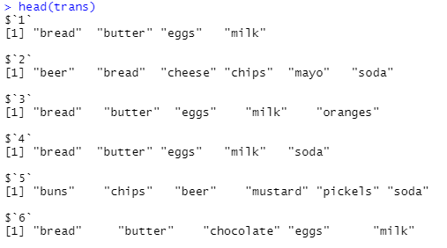

install.packages("arules")

library(arules)

rules=apriori(trans,parameter = list(support=0.5,confidence=0.9,maxlen=3,minlen=2))

inspect(rules)

